MATLAB Detector Tracker

Overview

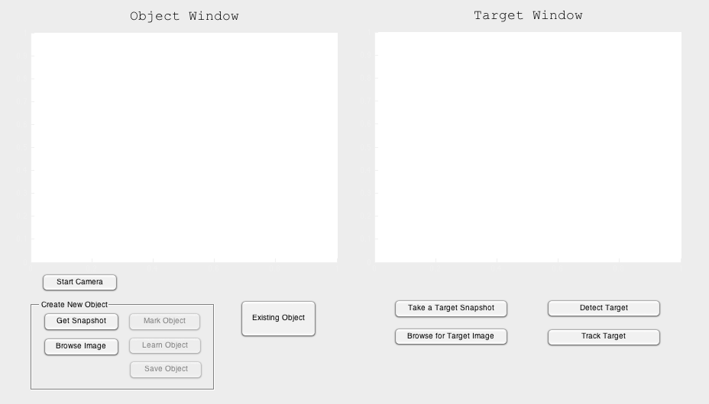

Figure : The program after it has been started.

**Getting started**

1. **Start the program**

When you have started the program you should have an open window that looks like Figure 1.

1. **Choose an object to track or detect**

After you have started the program you have three (3) options to choose from as seen in Figure 2.

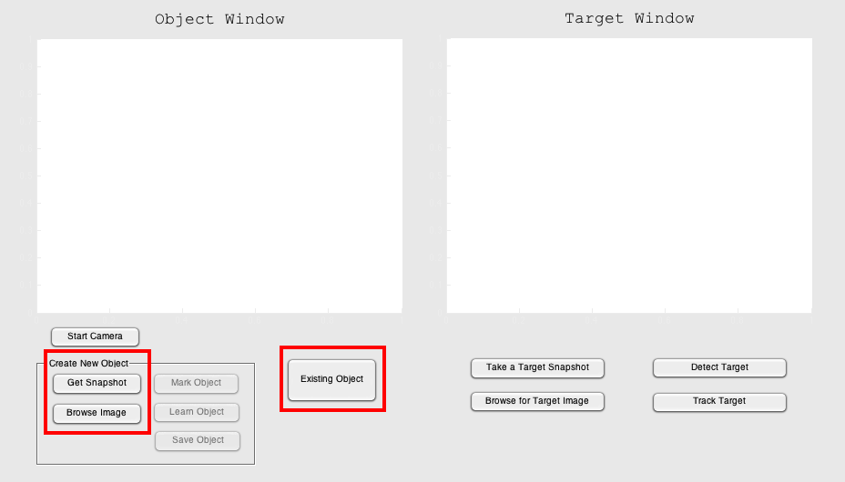

Figure : Click on one of these buttons

* 1. **Choose an image with an object**

In this option you will choose an image, which has not previously been marked. To choose an image, click on the Browse Image button, as seen in Figure 2. You will now get a prompt in which you will pick a file of your choosing and then click on open, as seen in Figure 3.

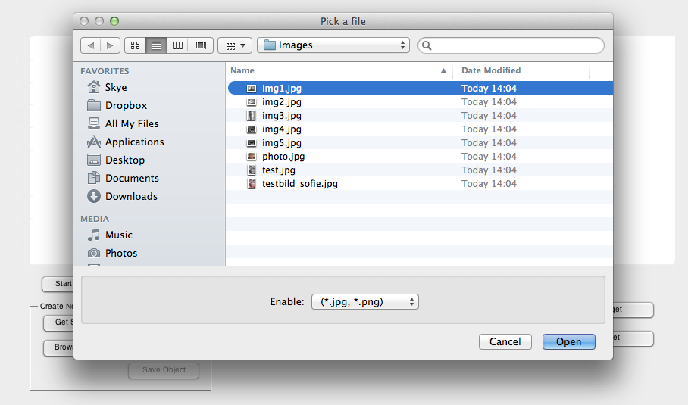

Figure :

* 1. **Take a snapshot**

To take a snapshot, click on the Get Snapshot button as seen in Figure 4.

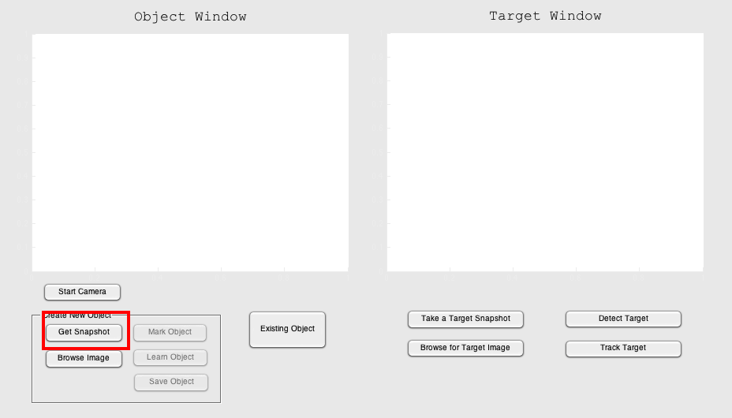

Figure :

Alternate option: Turn on the camera by pressing the Start Camera, a video feed will show up in the Target Window and you will be able to see what you are taking a snapshot of.

* 1. **Choose an existing object**

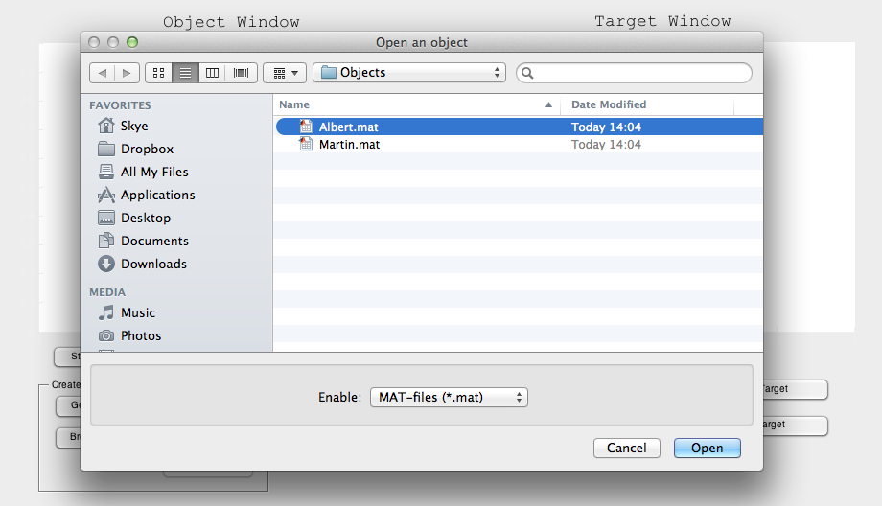

Figure : Choosing an object

1. **Marking the object**

Choose what to track by marking with a square in the Object Window, as seen in Figure 6. When you have marked what you wish to track simply wait until the Learn Object button becomes clickable. Move on to number 4.

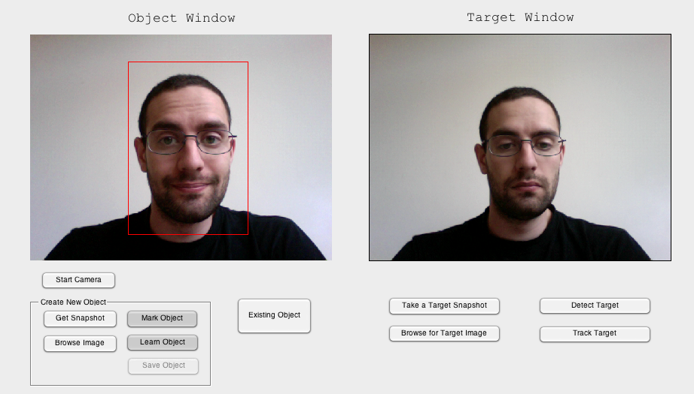

Figure : Mark the snapshot.

1. **Learning the object**

For the program to know what to track simply click the Learn Object button and the program will show you some feature points in a cropped image, as seen in Figure 7.

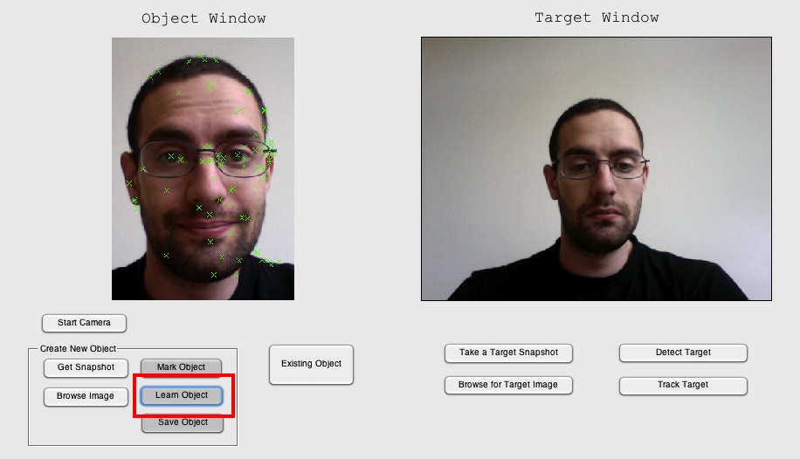

Figure : Learning the objec

* 1. **Saving the object**

To save your object for later use simply click the Save Object button and the window shown in Figure 8 will show up. Name your object and click on save. You have now saved your object.

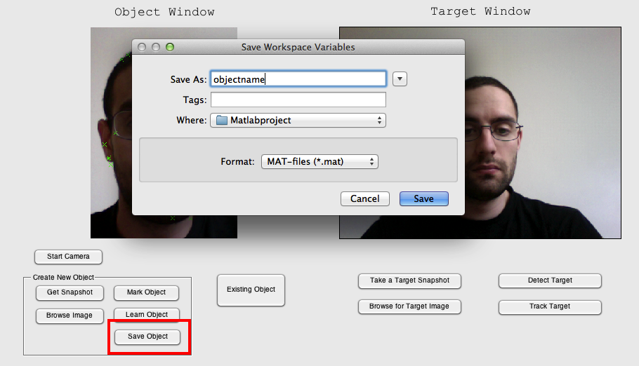

1. **Track or detect the object**